JUNEAU COUNTY FAIR SWINE IDENTIFICATION FORM
This form must be returned to the Juneau County Extension Office, 211 Hickory Street, Mauston, postmarked by May 1.

Name

4-H Club or FFA Chapter
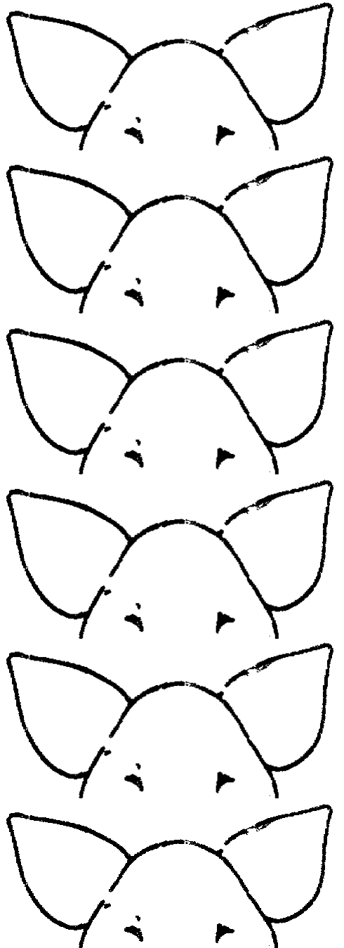

Ear Notches  (Draw in the ear notches on both  ears. Use Universal Ear Notching System) | Ear Tag # (Optional, can use your own tags) | Breed, Color, Markings | Sex

